Research Title

First Author¹ Second Author² Third Author³ and Fourth Author⁴
¹Program in Biology, Faculty of Science and Technology, SuratthaniRajabhat University,
Suratthani , 84100, Thailand
Tel: 0-77xx-xxxx, Fax: 0-77xx-xxxx, E-mail: xxxxxx@sru.ac.th
²Program in Agricultural, Faculty of Science, Songkla University, Songkla 90000, Thailand
Tel: 0-74xx-xxxx extxxxx, Fax: 0-74xx-xxxx, E-mail: xxxxxx@skru.ac.th

Abstract
This template contains the instructions to prepare your manuscript of SRU-national research conference 11th. Your manuscript will appear in A4 sized photocopy strictly the same as it is received. Please follow the template explicitly. The abstract must have only one paragraph and the length of abstract must not exceed 400 words. The abstract should include a concise statement of objectives and a summary of important results.

Keywords : word1, word2, word3 ( must have , between word each)

- INTRODUCTION
It is expected that authors will submit carefully written and proofread material. Spelling and grammatical errors, as well as language usage problems, are not acceptable. It is suggested that the paper length should on 6-8 pages.
Papers should clearly describe the background of the subject, problem statement, research objective, the authors work, the methods used, including the result and concluding discussion on the importance of the work. Papers are to be prepared in English (British or American) and SI-units shall be used. Technical terms should be explained unless they may be considered to be known to the broader nuclear community. Acronyms should be written out at their first appearance.
- RELATED WORKS
The uniform outlook of paper format will help the reader to follow the proceedings. This can be obtained most easily if authors use this template file to construct their papers. Please note the following details: this template is an A4 format with 1.8 inch top margins, 1.5 inch left margins, 1.0 inch right margins and 1.0 inch bottom margins.
All text paragraphs should be single spaced, with first line intended by 10 mm. Double spacing should only be used before and after headings and subheadings as shown in this example. Position and style of headings and subheadings should follow this example. No spaces should be placed between paragraphs. Please DO NOT change any of the above mentioned page, paragraph and font settings.

Header, Footer, Page Numbering
If this template is used when writing the full paper, headers and footers will be set automatically.

Fonts
Papers should use 16-point Angsana New font. The styles available are bold, italic and underlined. It is recommended that text in figures is not smaller than 12-point font size.

Tables and Figures
Figure captions and table headings should be sufficient to explain the figure or table without needing to refer to the text. Figures and tables not cited in the text should not be presented. Styles Heading Table and Caption Figure are available in this template for tables and figures. The following is the example for Table 1.
Table 1 : Title of Example Table
 |  | Head1 | Head2 | Head3
 | A
 | B
 | C

Tables and figures should be placed close after their first reference in the text. All figures and tables should be numbered with Arabic numerals. Table headings should be centered above the tables. Figure captions should be centered below the figures.
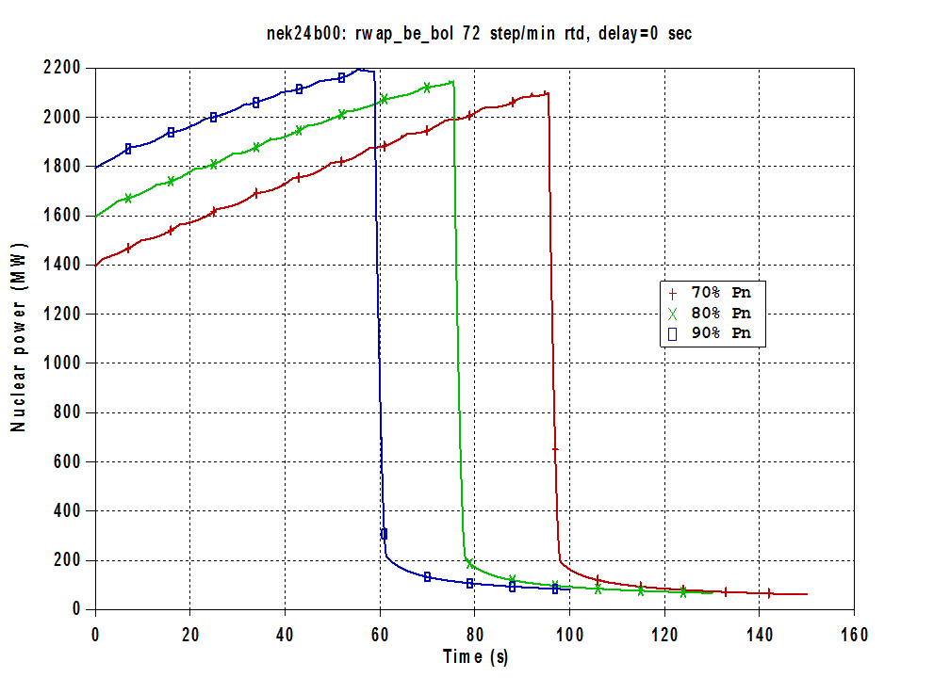
Figure 1: Hundertwasser’s Painting Sunset without Value (1970)

Equations
Each equation should be presented on a separate line from the text with a blank space above and below. Equations should be clear and expressions used should be explained in the text. The equations should be numbered consecutively at the outer right margin, as shown in Eq. (1) and (2) below. Here is one example. The number of different ways that a specified component can fail with (k-1) other components in a group of m similar components is:
(1)
Thus, the total failure probability, Qt, of component in a common cause group of m components is:
(2)

References
Reference numbers in the text should be designated by square brackets, e.g., [1]. The references should be listed in the same order as cited in the text. See also examples in the REFERNCES section of this template.
- METHODOLOGY
Summiting the paper is extended, the draft versions of the full paper could be submitted through Conference by 10th August, 2015. Final version of the paper and abstract should be submitted by 20th August 2015.
There are 2 files that have to be summited in final state include of the full final paper –all parts of the paper- and the abstract-only title, author, abstract and key words – by e-mail : research-sru@hotmail.com.
- IMPLEMENTATION
The abstracts and final papers are compiled into the conference Proceedings USB.
- RESULT
Result should answer main hypothesis or research question (s).
- CONCLUSION & DISCUSSION
Conclusions should state concisely the most important propositions of the paper as well as the author’s views of the practical implications of the results.

REFERENCES
- International Atomic Energy Agency, “Procedures for Conducting Common Cause Failure Analysis in Probabilistic Safety Assessment”, IAEA-TECDOC-648, 1992
- K.N. Fleming, S.B. Rao, G.A. Tinsley, A. Mosleh, A. Afzali, “A Database of Common-Cause Events for Risk and Reliability Applications”, EPRI TR-100382, Electric Power Research Institute, Paolo Alto, CA., 1992
- A. Mosleh, K.N. Fleming, G.W. Parry, H.M. Paula, D.M. Rasmuson, D.H. Worledge, “Procedures for Treating Common Cause Failures in Safety and Reliability Studies”, NUREG/CR-4780, EPRI NP-5613, Electric Power Research Institute, Paolo Alto, CA., Vol. 1 (1998), Vol. 2 (1999)
- Relcon AB, “Risk Spectrum Professional User’s Manual”, 1998

